Progression in calculations Year 1 – Year 6*

1

Progression in calculations Year 1
National curriculum objectives linked to addition and subtraction

These objectives are explicitly covered through the strategies outlined in this document:

- Add and subtract one-digit and two-digit numbers to 100, including zero (N.B. Year 1 N.C. objective is to do this with numbers to 20).

- Add and subtract numbers using concrete objects, pictorial representations, and mentally, including: a two-digit number and ones, a two-digit number and tens, 2 two-digit numbers; add 3 one-digit numbers (Year 2).
- Represent and use number bonds and related subtraction facts within 20.

- Given a number, identify 1 more and 1 less.

- Show that addition of two numbers can be done in any order (commutative) but subtraction of one number from another cannot (Year 2).

- Recognise the inverse relationship between addition and subtraction and use this to solve missing number problems (Year 2).

The following objectives should be planned for lessons where new strategies are being introduced and developed:

- Read, write and interpret mathematical statements involving addition (+), subtraction (−) and equal (=) signs.

- Solve one-step problems that involve addition and subtraction, using concrete objects and
pictorial representations, and missing number problems, such as 7 = □ − 9.

- Solve problems with addition and subtraction:

  - Using concrete objects and pictorial representations, including those involving numbers, quantities and measures

  - Applying their increasing knowledge of mental methods

Teachers should refer to the definitions and guidance on the structures for addition and subtraction to provide a range of appropriate real-life contexts for calculations.

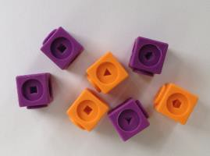
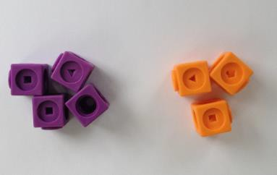
Y1 Addition

Strategy & guidance | CPA
Count all  Joining two groups and then recounting all objects using one-to- one correspondence | 3 + 4 = 7 | 5 + 3 = 8
Counting on  As a strategy, this should be limited to adding small quantities only (1, 2 or  3) with pupils understanding that counting on from the greater number is more efficient. | 8 + 1 = 9  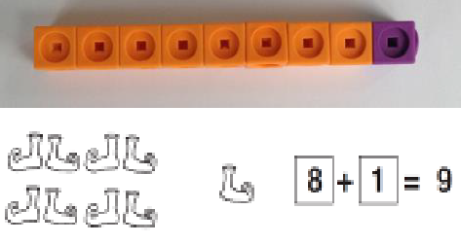 | 15 = 12 + 3  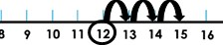
Part-part-whole  Teach both addition and subtraction alongside each other, as pupils will use this model to identify the inverse relationship between them.  This model begins to develop the understanding of the commutativity of addition, as pupils become aware that the parts will make the whole in any order. | 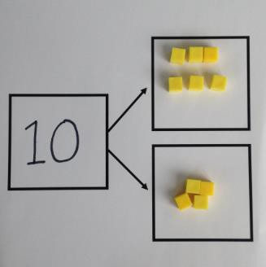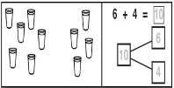  10 = 6 + 4  10 − 6 = 4  10 − 4 = 6  10 = 4 + 6

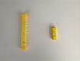
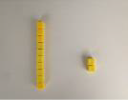
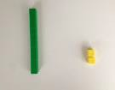
Regrouping ten ones to make ten  This is an essential skill that will support column addition later on. | 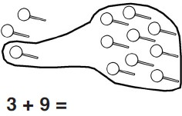 3 + 9 = 12
‘Make ten’ strategy  Pupils should be encouraged to start at the greater number and partition the smaller number to make ten.  The colours of the beads on the bead string make it clear how many more need to be added to make ten.  Also, the empty spaces on the ten frame make it clear how many more are needed to make ten. | 6 + 5 = 11  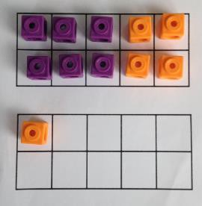 | 4 + 9 = 13
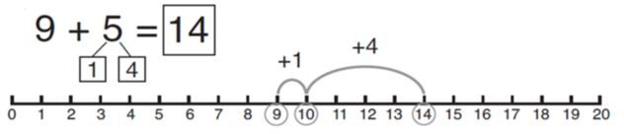

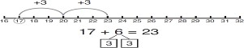

Adding 1, 2, 3 more  Here the emphasis should be on the language rather than the strategy. As pupils are using the beadstring, ensure that they are explaining using language such as;  ‘1 more than 5 is equal  to 6.’  ‘2 more than 5 is equal  to 7.’  ‘8 is 3 more than 5.’  Over time, pupils should be encouraged to rely more on their number bonds knowledge than on counting strategies. | - more than 5 5 + 1 = 6  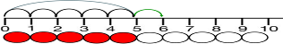  - more than 5 5 + 2 = 7  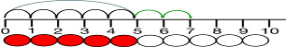  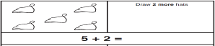
Adding three single digit numbers (make ten first)  Pupils may need to try different combinations before they find the two numbers that make 10.  The first bead string shows 4, 7 and 6. The colours of the bead string show that it makes more than ten.  The second bead string shows 4, 6 and then 7.  The final bead string shows how they have now been put together to find the total. | 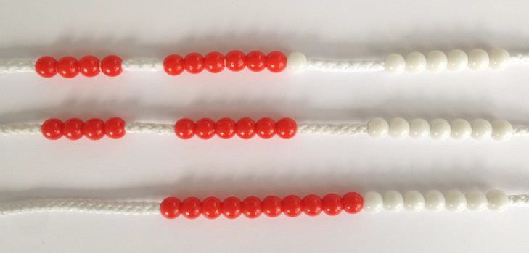  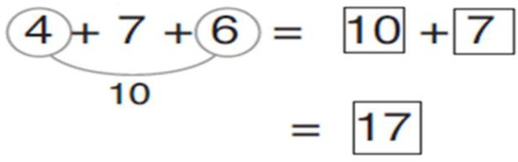

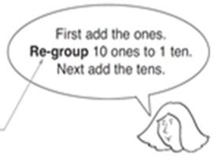
Partitioning to add (no regrouping)  Place value grids and Dienes blocks could be used as shown in the diagram before moving onto pictorial representations. Dienes blocks should always be available, as the main focus in Year 1 is the concept of place value rather than mastering the procedure.  When not regrouping, partitioning is a mental strategy and does not need formal recording in columns. This representation prepares them for using column addition with formal recording. | 24 + 13 = 37  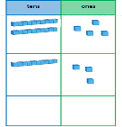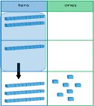  24 + 13 = 37
Introducing column method for addition, regrouping only  Dienes blocks and place value grids should be used as shown in the diagrams. Even when working pictorially, pupils should have access to Dienes blocks.  See additional guidance on unit pages for extra guidance on this strategy. | 24 + 17  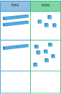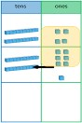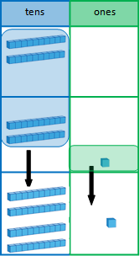  Tens Ones  2 4  + 1 7 .  1  .  4 1

Adding multiples of ten  Using the vocabulary of 1 ten, 2 tens, 3 tens  etc. alongside 10, 20, 30 is important, as pupils need to understand that it is a ten and not a one that is being added and they need to understand that a ‘2’ digit in the tens column has a value of twenty.  It also emphasises the link to known number facts. E.g. ‘2 + 3 is  equal to 5. So 2 tens + 3 tens is equal to 5 tens. | 50 = 30 + 20  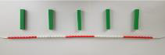  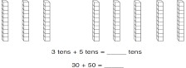  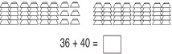

Y1 Subtraction

Strategy & guidance | CPA
Taking away from the ones  When this is first introduced, the concrete representation should be based upon the diagram. Real objects should be placed on top of the images as one-to-one correspondence so that pupils can take them away, progressing to representing the group of ten with a tens rod and ones with ones  cubes. | 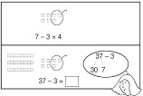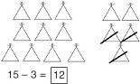  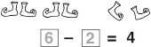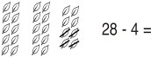
Counting back Subtracting 1, 2, or 3 by counting back  Pupils should be encouraged to rely on number bonds knowledge as time goes on, rather than using counting back as their main strategy. | 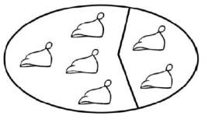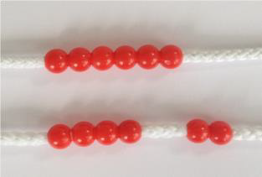  4 = 6 − 2 | 16 – 2 = 14  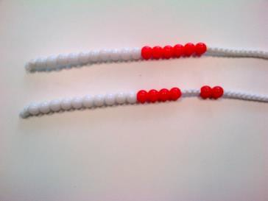  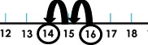

Part-part-whole Teach both addition and subtraction alongside each other, as the pupils will use this model to identify the link between them. Pupils start with ten cubes placed on the whole.  They then remove what is being taken away from the whole and place it on one of the parts.  The remaining cubes are the other part and also the answer. These can be moved into the  second part space. | 10 − 6 = 4  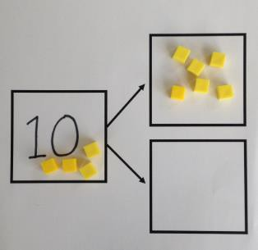  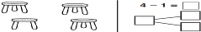
Make ten strategy To subtract a 1-digit number from a 2-digit number.  Pupils identify how many need to be taken away to make ten first, partitioning the number being subtracted. Then they take away the rest to  reach the answer. | 14 – 5 = 9  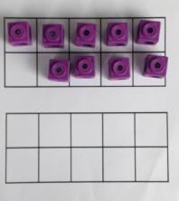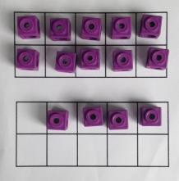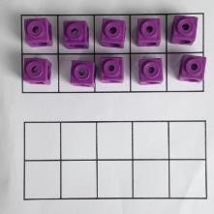  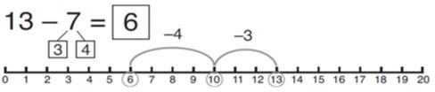
Regroup a ten into 10 ones  After the initial introduction, the Dienes blocks should be placed on a place value chart to support place value understanding. This will support pupils when they later use the column method. | 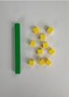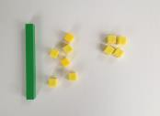  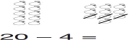

Taking away from the tens  Pupils should identify that they can also take away from the tens and get the same answer.  This reinforces their knowledge of number bonds to 10 and develops their application of number bonds for mental strategies. | 9 = 15− 6  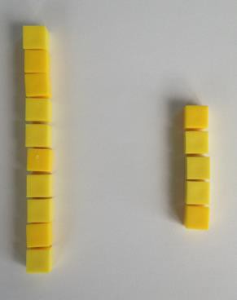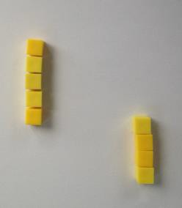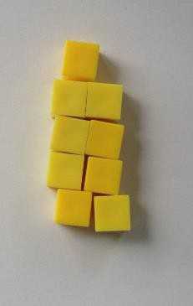  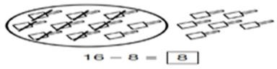
Partitioning to subtract without regrouping  Dienes blocks on a place value chart (developing into using images on the chart) could be used, as when adding 2-digit numbers, reinforcing the main concept of place value for Year 1.  When not regrouping, partitioning is a mental strategy and does not need formal recording in columns. This representation prepares them for using column subtraction with formal recording. | 34 − 13 = 21  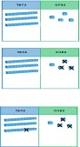  34 – 13 = 21

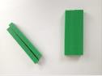
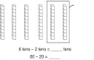
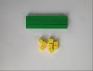
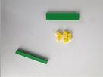
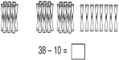
Subtracting multiples of ten Using the vocabulary of 1 ten, 2 tens, 3 tens  etc. alongside 10, 20, 30 is important as pupils need to understand that it is a ten not a one that is being taken away. | 40 = 60 – 20 | 38 − 10 = 28
Column method with regrouping This example shows how pupils should work practically when being introduced to this method.  There is no formal recording in columns in Year 1 but this practical work will prepare pupils for formal methods in Year 2.  See additional guidance on unit pages to support with this method. | 34 − 17 = 17  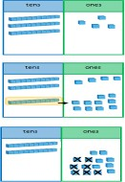  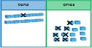

National Curriculum objectives linked to multiplication and division

These objectives are explicitly covered through the strategies outlined in this document:

- Solve one-step problems involving multiplication and division, by calculating the answer using concrete objects, pictorial representations and arrays with the support of the teacher.

Teachers should refer to definitions and guidance on the structures for multiplication and division to provide a range of appropriate real-life contexts for calculations.

Y1 Multiplication

Strategy & guidance | CPA
Skip counting in multiples of 2, 5, 10 from zero  The representation for the amount of groups supports pupils’ understanding of the written equation. So two groups of 2 are 2, 4. Or five  groups of 2 are 2, 4, 6, 8, 10.  Count the groups as pupils are skip counting.  Number lines can be used in the same way as the bead string.  Pupils can use their fingers as they are skip counting. | 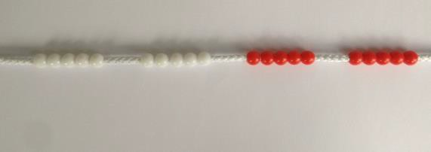  4 × 5 = 20  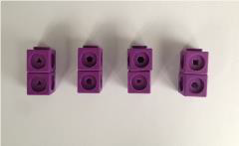  2 × 4 = 8
Making equal groups and counting the total  How this would be represented as an equation will vary. This could be 2 × 4 or 4 × 2. The importance should be placed on the vocabulary used alongside the equation. So this picture could represent 2 groups of 4 or 4 twice. | 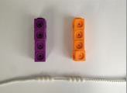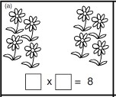

Solve multiplications using repeated addition  This strategy helps pupils make a clear link between multiplication and division as well as exemplifying the ‘repeated addition’ structure for multiplication. It is a natural progression from the previous ‘count all’ strategy as pupils can be encouraged to ‘count on’.  However, as number bonds knowledge grows, pupils should rely more on these important facts to calculate efficiently. | 3 x 3 = 3 + 3 + 3  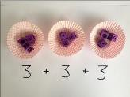  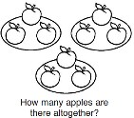  3 + 3 + 3 = 9

Y1 Division

Strategy & guidance | CPA
Sharing objects into groups  Pupils should become familiar with division equations through working practically.  The division symbol is not formally taught at this stage. | 10 ÷ 2 = 5  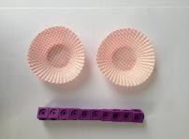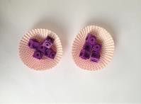  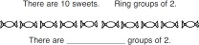  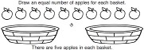

Progression in calculations Year 2
National Curriculum objectives linked to addition and subtraction

These objectives are explicitly covered through the strategies outlined in this document:

- Add and subtract numbers using concrete objects, pictorial representations, and mentally, including: a two-digit number and ones; a two-digit number and tens; 2 two-digit numbers; adding three one-digit numbers.

- Add and subtract numbers mentally, including: a three-digit number and ones; a three-digit number and tens; a three-digit number and hundreds (Year 3).

- Recall and use addition and subtraction facts to 20 fluently, and derive and use related facts up to 100.

- Find 10 or 100 more or less than a given number (Year 3).
- Show that addition of two numbers can be done in any order (commutative) but subtraction of one number from another cannot.

- Recognise and use the inverse relationship between addition and subtraction and use this to check calculations and solve missing number problems.

- Add and subtract numbers with up to three digits, using formal written methods of columnar addition and subtraction (Year 3).

The following objectives should be planned for lessons where new strategies are being introduced and developed:
- Solve problems with addition and subtraction: using concrete objects and pictorial representations, including those involving numbers, quantities and measures; apply increasing knowledge of mental and written methods.

- Solve problems, including missing number problems, using number facts, place value and more complex addition and subtraction. (Year 3)

Teachers should refer to the definitions and guidance on the structures for addition and subtraction to provide a range of appropriate real-life contexts for calculations.

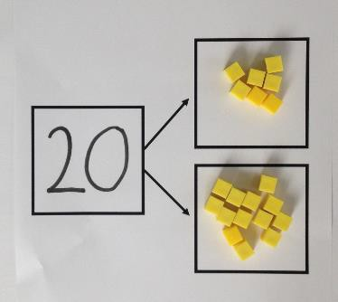
Y2 Addition

Strategy & guidance | CPA
Part-part-whole  Pupils explore the different ways of making 20. They can do this with all numbers using the same representations.  This model develops knowledge of the inverse relationship between addition and subtraction and is used to find the answer to missing number problems. | 20 = 17 + 3  20 = 3 + 17  20 – 3 = 17  20 – 17 = 3  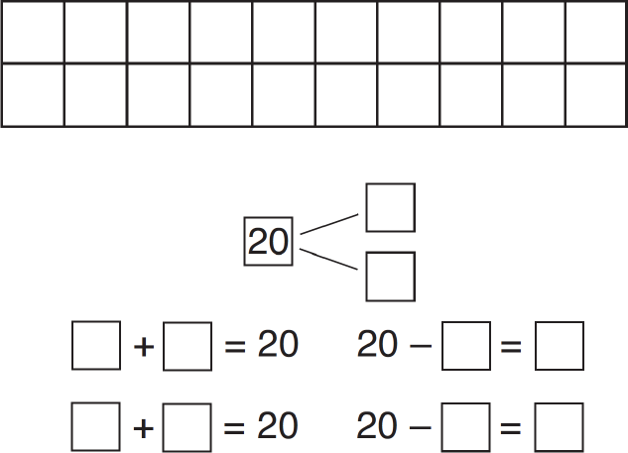  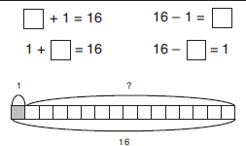
Counting on in tens and hundreds | 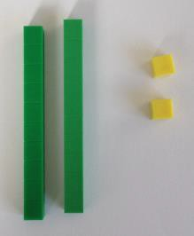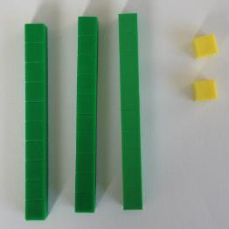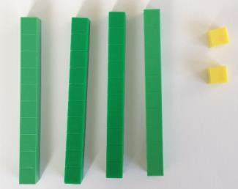  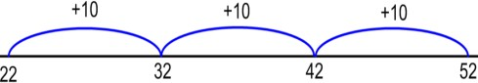  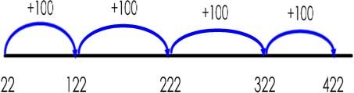

Strategy & guidance | CPA
Using known facts to create derived facts  Dienes blocks should be used alongside pictorial and abstract representations when introducing this strategy. | 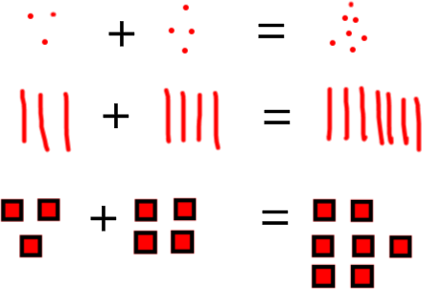 | 3 + 4 = 7  leads to  30 + 40 = 70  leads to  300 + 400 = 700
Partitioning one number, then adding tens and ones  Pupils can choose themselves which of the numbers they wish to partition. Pupils will begin to see when this method is more efficient than adding tens and taking away the extra ones, as shown. | 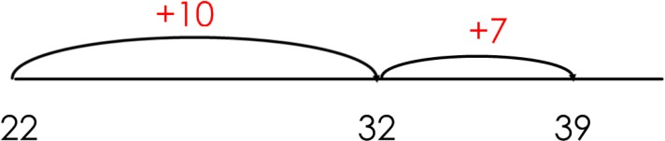  22 + 17 = 39
Round and adjust (sometimes known as a compensating strategy)  Pupils will develop a sense of efficiency with this method, beginning to see when rounding and adjusting is more efficient than adding tens and then ones. | 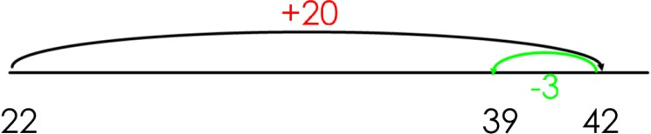  22 + 17 = 39

Strategy & guidance | CPA
Make ten strategy  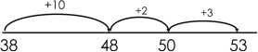  How pupils choose to apply this strategy is up to them; however, the focus should always be on efficiency.  It relies on an understanding that numbers can be partitioned in different ways in order to easily make a multiple of ten. | 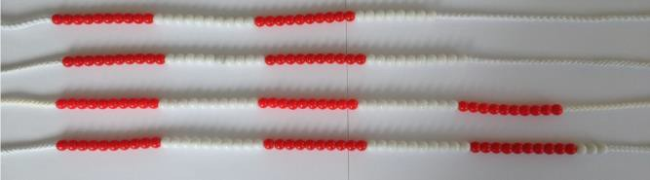  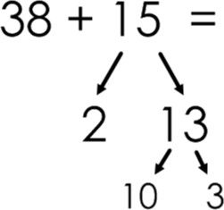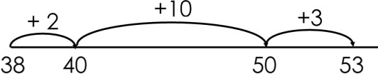
Partitioning to add without regrouping  As in Year 1, this is a mental strategy rather than a formal written method. Pupils use the Dienes blocks (and later, images) to represent 3- digit numbers but do not record a formal written method if there is no regrouping. | 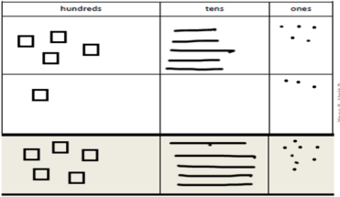  4 5 5 + 1 0 3 = 5 5 8
Column method with regrouping  Dienes blocks should be used alongside the pictorial representations; they can be placed on the place value grid before pupils make pictorial representations.  As in Year 1, the focus for the column method is to develop a strong understanding of place value. | 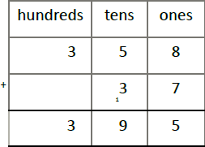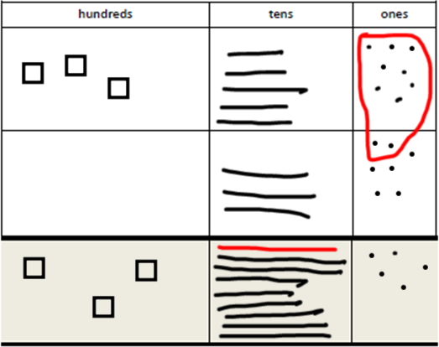

Y2 Subtraction

Strategy & guidance | CPA
Counting back in multiples of ten and one hundred | 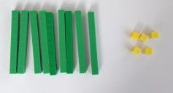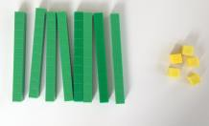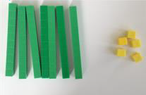  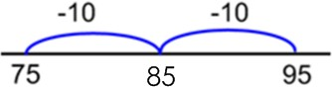  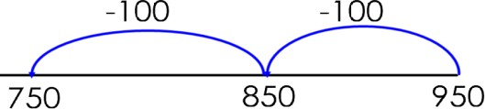
Using known number
facts to create derived
facts |  | 8 − 4 = 4
Dienes blocks should be |  | leads to
used alongside pictorial
and abstract |  | 80 − 40 = 40
representations when  introducing this strategy, |  | leads to
encouraging pupils to  apply their knowledge of |  | 800 − 400 = 400
number bonds to add
multiples of ten and 100.
Subtracting tens and ones  Pupils must be taught to partition the second number for this strategy as partitioning both numbers can lead to errors if regrouping is required. | 53 − 12 = 41  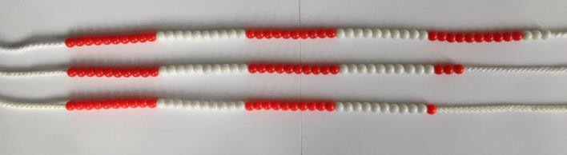  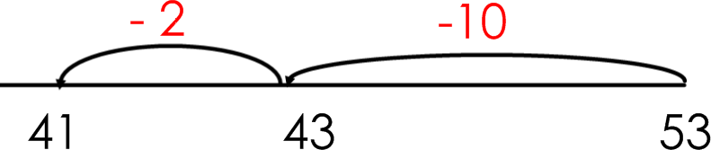

Strategy & guidance | CPA
Round and adjust (sometimes known as a compensating strategy)  Pupils must be taught to round the number that is being subtracted.  Pupils will develop a sense of efficiency with this method, beginning to identify when this method is more efficient than subtracting tens and then ones. | 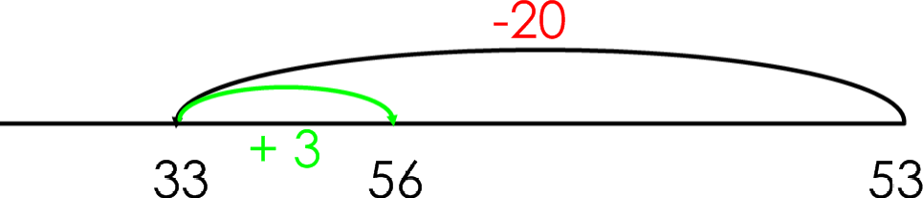  53 − 17 = 36
Make ten  How pupils choose to apply this strategy is up to them. The focus should always be on efficiency.  It relies on an understanding that numbers can be partitioned in different ways in order to subtract to a multiple of ten.  Pupils should develop an understanding that the parts can be added in any order. | 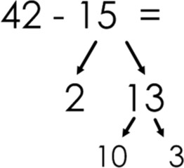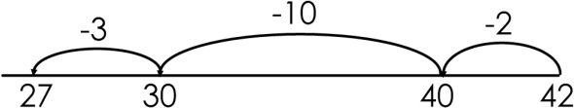  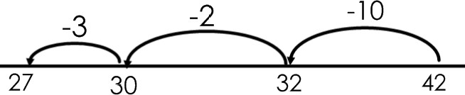

Strategy & guidance | CPA
Partitioning to subtract without regrouping  As in Year 1, the focus is to develop a strong understanding of place value and pupils should always be using concrete manipulatives alongside the pictorial.  Formal recording in columns is unnecessary for this mental strategy. It prepares them to subtract with 3-digits when regrouping is required. | 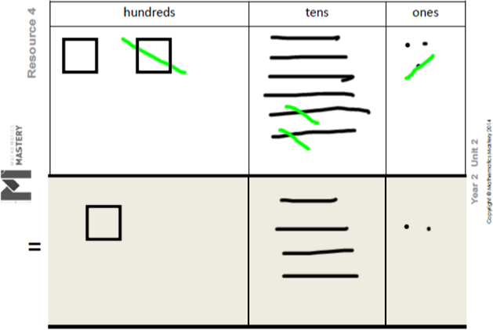  263 − 121= 142
Column method with regrouping  The focus for the column method is to develop a strong understanding of place value and concrete manipulatives should be used alongside.  Pupils are introduced to calculations that require two instances of regrouping (initially from tens to one and then from hundreds to tens). E.g. 232  – 157 and are given plenty of practice using concrete manipulatives and images alongside their formal written methods, ensuring that important steps are not missed in the recording.  Caution should be exercised when introducing calculations requiring ‘regrouping to regroup’ (e.g. 204 – 137) ensuring ample teacher modelling using concrete manipulatives and images. | 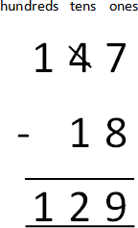  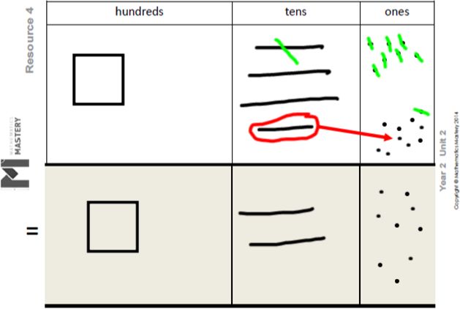

National Curriculum objectives linked to multiplication and division

These objectives are explicitly covered through the strategies outlined in this document:

- Recall and use multiplication and division facts for the 2, 5 and 10 multiplication tables, including recognising odd and even numbers.
- Recall and use multiplication and division facts for the 3 and 4 multiplication tables (Year 3).

- Show that multiplication of two numbers can be done in any order (commutative) but division of one number by another cannot.

The following objectives should be planned for lessons where new strategies are being introduced and developed:
- Calculate mathematical statements for multiplication and division within the multiplication tables and write them using the multiplication (×), division (÷) and equal (=) signs.
- Solve problems involving multiplication and division, using materials, arrays, repeated addition, mental methods and multiplication and division facts, including problems in context.

Teachers should refer to definitions and guidance on the structures for multiplication and division to provide a range of appropriate real-life contexts for calculations.

Y2 Multiplication

Strategy & guidance | CPA
Skip counting in multiples of 2, 3, 4, 5,  10 from zero  Pupils can use their fingers as they are skip counting, to develop an understanding of ‘groups of’.  Dot arrays can be used to create a visual representation for the different multiplication facts. Bead strings, groups of cubes (or unifix  / multilink towers) provide useful concrete representations. | 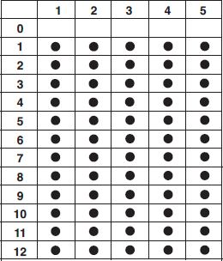
Multiplication as repeated addition  Pupils apply skip counting to help find the totals of repeated additions. | 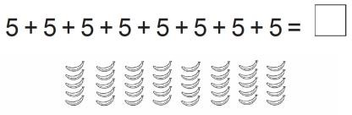  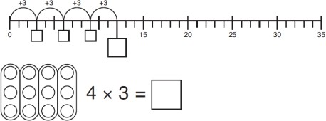

Strategy & guidance | CPA
Arrays to represent multiplication equations  Concrete manipulatives and images of familiar objects begin to be organised into arrays and, later, are shown alongside dot arrays. It is important to discuss with pupils how arrays can be useful.  Pupils begin to understand multiplication in a more abstract fashion, applying their skip counting skills to identify the multiples of the 2x, 5x and 10x tables.  The relationship between multiplication and division also begins to be demonstrated. | 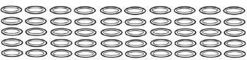  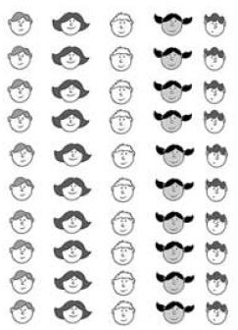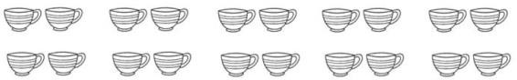
Multiplication is commutative  Pupils should understand that an array and, later, bar models can represent different equations and that, as multiplication is commutative, the order of the multiplication does not affect the answer. | 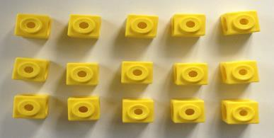  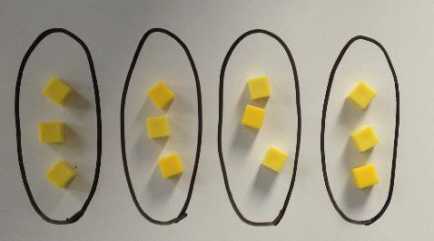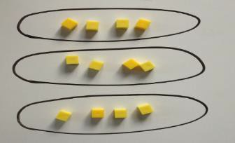  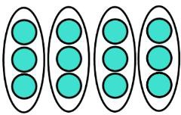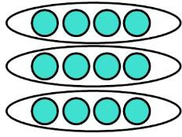  12 = 3 × 4 12 = 4 × 3

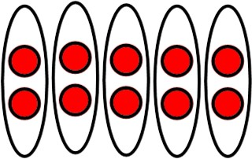
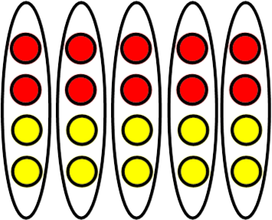
Strategy & guidance | CPA
Use of part-part- whole model to establish the inverse relationship between multiplication and division  This link should be made explicit from early on, using the language of the part-part-whole model, so that pupils develop an early understanding of the relationship between multiplication and division. Bar models (with Cuisenaire rods) should be used to identify the whole, the value of the parts and the number of parts.  It is important to highlight that with multiplication, the parts are of equal value as this is different to how this model is used for addition and subtraction. | There are three equal parts. Each part has a value of three. What is the whole?  3 × 3 = 9 ÷ 3 =  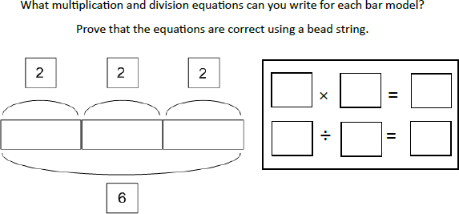
Doubling to derive new multiplication facts  Pupils learn that known facts from easier multiplication tables can be used to derive facts from related times tables using doubling as a strategy.  At this stage they double the 2× table facts to derive the 4× table facts. | 5 × 2 = 10  5 × 4 = 20

Y2 Division

Strategy & guidance | CPA
Division as sharing  Here, division is shown as sharing.  If we have ten pairs of scissors and we share them between two pots, there will be 5 pairs of scissors in each pot. | 10 ÷ 2 = 5  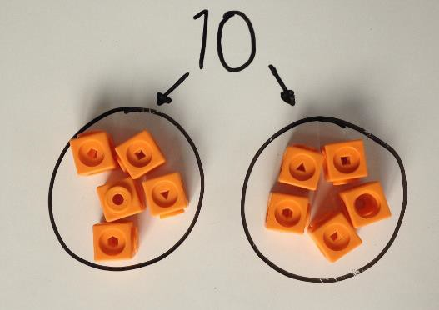  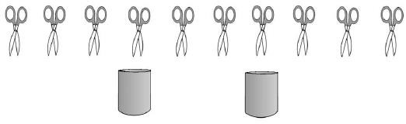
Division as grouping  Here, division is shown as grouping.  If we have ten forks and we put them into groups of two, there are 5 groups. | 10 ÷ 2 = 5  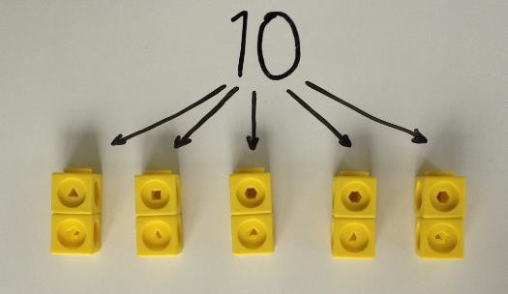  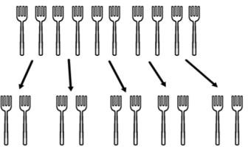

Strategy & guidance | CPA
Use of part-part-whole model to represent division equations and to emphasise the relationship between division and multiplication  Pupils use arrays of concrete manipulatives and images of familiar objects to solve division equations.  They begin to use dot arrays to develop a more abstract concept of division.  It is important to highlight that with multiplication and division, the parts are of equal value as this is different to how this model is used for addition and subtraction. | 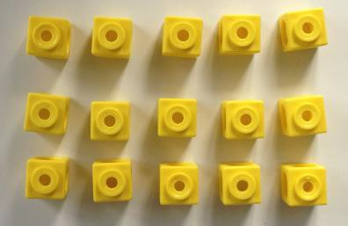  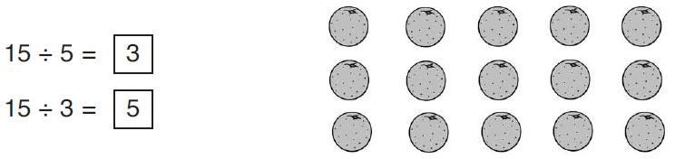  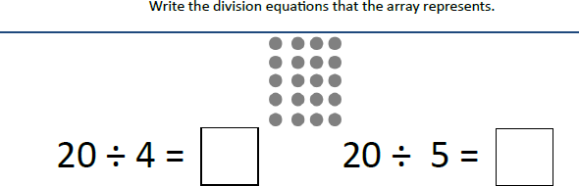  The whole is nine. There are three equal parts. What is the value of each part? 9 ÷ 3 =

Progression in calculations Year 3
National Curriculum objectives linked to addition and subtraction

These objectives are explicitly covered through the strategies outlined in this document:

- add and subtract numbers mentally, including:

  - a three-digit number and ones

  - a three-digit number and tens

  - a three-digit number and hundreds
- add and subtract numbers with up to four digits, using formal written methods of columnar addition and subtraction (four digits is Year 4)
- find 10 or 100 more or less than a given number

- find 1 000 more or less than a given number (Year 4)

- estimate the answer to a calculation and use inverse operations to check answers

The following objectives should be planned for lessons where new strategies are being introduced and developed:

- solve problems, including missing number problems, using number facts, place value, and more complex addition and subtraction

Teachers should refer to definitions and guidance on the structures for addition and subtraction to provide a range of appropriate real-life contexts for calculations.

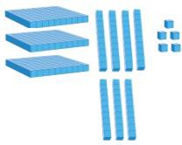

Y3 Addition & Subtraction

Strategy & guidance | CPA
Add and subtract numbers mentally, including:  - a three-digit number and ones;  - a three-digit number and tens;  - a three-digit number and hundreds  Pupils learn that this is an appropriate strategy when they are able to use known and derived number facts or other mental strategies to complete mental calculations with accuracy.  To begin with, some pupils will prefer to use this strategy only when there is no need to regroup, using number facts within 10 and derivations. More confident pupils might choose from a range of mental strategies that avoid written algorithms, including (but not exhaustively):  - known number facts within 20,  - derived number facts,  - ‘Make ten’,  - round and adjust  See Year 2 guidance for exemplification of these – the use of concrete manipulatives other than Dienes blocks is important in reinforcing the use of these strategies.  It is important that pupils are given plenty of (scaffolded) practice at choosing their own strategies to complete calculations efficiently and accurately.  Explicit links need to be made between familiar number facts and the calculations that they can be useful for and pupils need to be encouraged to aim for efficiency. | It is important to model the mental strategy using concrete manipulatives in the first instance and pupils should be able to exemplify their own strategies using manipulatives if required, with numbers appropriate to the unit they are working on (3-digit numbers in Units 1 & 4; 4-digit numbers in Unit 13). However, pupils should be encouraged to use known facts to derive answers, rather than relying on counting manipulatives or images.  No regrouping  345 + 30 274 - 50  1128 + 300 1312 - 300  326 + 342 856 - 724  I know 4 + 3 = 7,  so 4 tens plus 3 tens is equal to 7 tens.  345 + 30 = 375.  With some regrouping  416 + 25 232 - 5  383 + 130 455 - 216  611 + 194 130 - 40  1482 + 900 2382 - 500

Strategy & guidance | CPA
Written column method for calculations that require regrouping with up to 4-digits  Dienes blocks should be used alongside the pictorial representations during direct teaching and can be used by pupils both for support and challenge. Place value counters can also be introduced at this stage.  This work revises and reinforces ideas from Key Stage 1, including the focus on place value – see Year 2 exemplification.  Direct teaching of the columnar method should require at least one element of regrouping, so that pupils are clear about when it is most useful to use it. Asking them ‘Can you think of a more efficient method?’ will challenge them to apply their number sense / number facts to use efficient mental methods where possible.  As in Year 2, pupils should be given plenty of practice with calculations that require multiple separate instances of regrouping. In Year 3 they become more familiar with calculations that require ‘regrouping to regroup’. Understanding must be secured through the considered use of manipulatives and images, combined with careful use of language.  Pupils should be challenged as to whether this is the most efficient method, considering whether mental methods (such as counting on, using known number facts, round and adjust etc.) may be likelier to produce an accurate solution.  Pupils requiring support might develop their confidence in the written method using numbers that require no regrouping.  See Unit materials for extra guidance on this strategy. | As for the mental strategies, pupils should be exposed to concrete manipulatives modelling the written calculations and should be able to represent their written work pictorially or with concrete manipulatives when required.  Again, they should be encouraged to calculate with known and derived facts and should not rely on counting images or manipulatives.  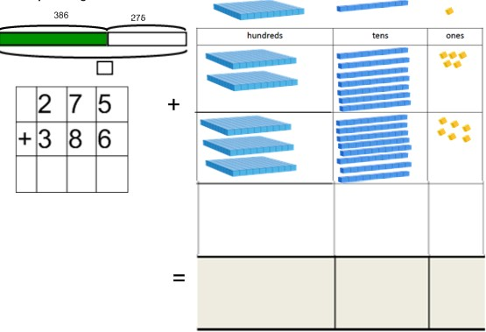  5 + 6 = 11 so I will have 11 ones which I regroup for 1 ten and 1 one.  Regrouping (including multiple separate instances)  672 + 136 734 – 82  468 + 67 831 - 76  275 + 386 435 – 188  ‘Regrouping to regroup’  204 – 137  1035 - 851

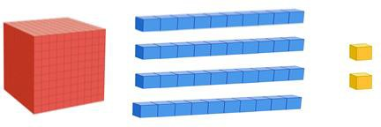
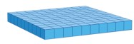
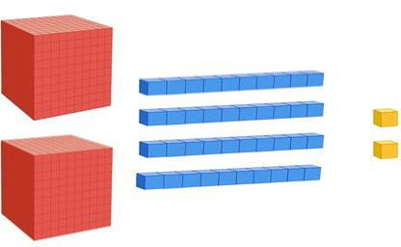
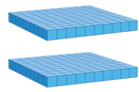
Strategy & guidance | CPA
Find 10, 100 more or less than a given number  As pupils become familiar with numbers up to 1000, place value should be emphasised and comparisons drawn between adding tens, hundreds (and, in the last unit of the Summer term, thousands), including use of concrete manipulatives and appropriate images.  After initial teaching, this should be incorporated into transition activities and practised regularly. | 142 + 100 = 242

National Curriculum objectives linked to multiplication and division

These objectives are explicitly covered through the strategies outlined in this document:

- count from 0 in multiples of 4, 8, 50 and 100

- recall and use multiplication and division facts for the 3, 4, 6, and 8 multiplication tables

- write and calculate mathematical statements for multiplication and division using the multiplication tables that they know, including for two-digit numbers times one-digit numbers, using mental methods

- solve problems, including missing number problems, involving multiplication and division, including positive integer scaling problems and correspondence problems in which n objects are connected to m objects

Teachers should refer to definitions and guidance on the structures for multiplication and division to provide a range of appropriate real-life contexts for calculations.

Y3 Multiplication

Strategy & guidance | CPA
Doubling to derive new multiplication facts  Pupils continue to make use of the idea that facts from easier times tables can be used to derive facts from related times tables using doubling as a strategy.  This builds on the doubling strategy from Year 2. | 3 x 3 = 9 3 x 6 = double 9 = 18  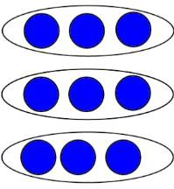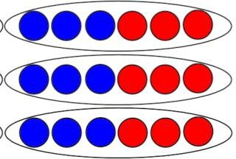

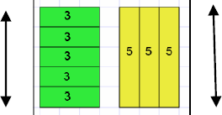
Strategy & guidance | CPA
Skip counting in multiples of 2, 3, 4, 5,  6, 8 and 10  Rehearsal of previously learnt tables as well as new content for Year 3 should be incorporated into transition activities and practised regularly. | 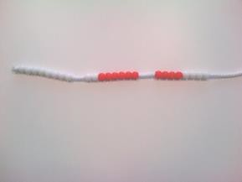
Use of part-part- whole model with arrays and bar models to establish commutativity and inverse relationship between multiplication and division

In these contexts pupils are able to identify all the equations in a fact family.
Ten times greater

Pupils’s work on this must be firmly based on concrete representations
– the language of ten times greater must be well modelled and understood to prevent the numerical misconception of ‘adding a zero’.

Strategy & guidance | CPA
Multiplying by 10 and 100  Building on the ten times greater work, pupils use appropriate Dienes blocks and place value counters to multiply 2, 3,  4, 5 and 10 by 10, 100  and 1000. | 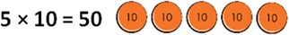
Using known facts for multiplying by multiples of 10 and 100  Pupils’ growing understanding of place value, allows them to make use of known facts to derive multiplications using powers of 10.  It is important to use tables with which they are already familiar (i.e. not 7 or 9 tables in Year 3) | 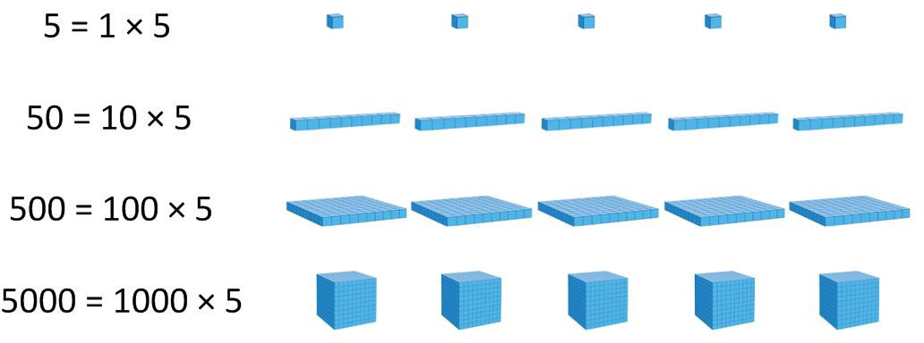  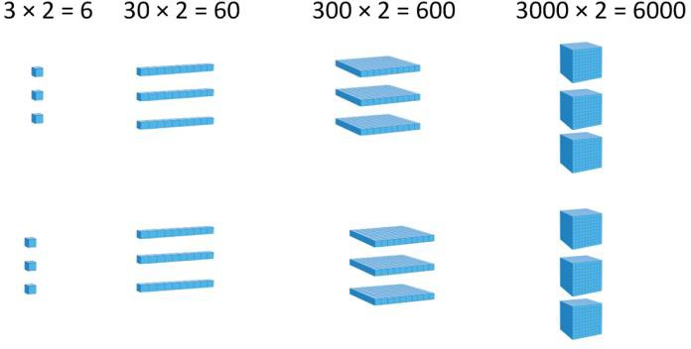

Strategy & guidance | CPA
Multiplication of 2- digit numbers with partitioning (no regrouping)  Children should always consider whether partitioning is the best strategy – if it is possible to use strategies such as doubling (some may use doubling twice for ×4), they need to choose the most efficient strategy.  Children may wish to make jottings, including a full grid as exemplified here – but grid method is not a formal method and its only purpose is to record mental calculations. This supports the development of the necessary mental calculating skills but does not hinder the introduction of formal written methods in Year  4. Concrete manipulatives are essential to develop understanding. | 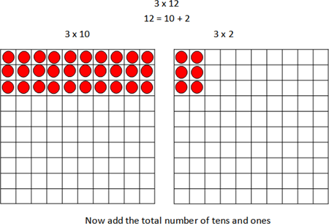  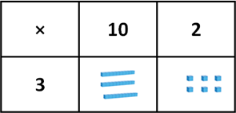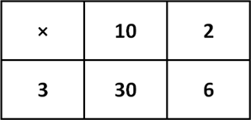
 | 3 x 12 = 36

Strategy & guidance | CPA
Multiplication of 2- digit numbers with partitioning (regrouping)  Using concrete manipulatives and later moving to using images that represent them, supports pupils’ early understanding, leading towards formal written methods in Year 4.  Once again, this is a mental strategy, which they may choose to support with informal jottings, including a full grid, as exemplified here.  Pupils must be encouraged to make use of their known multiplication facts and their knowledge of place value to calculate, rather than counting manipulatives. | 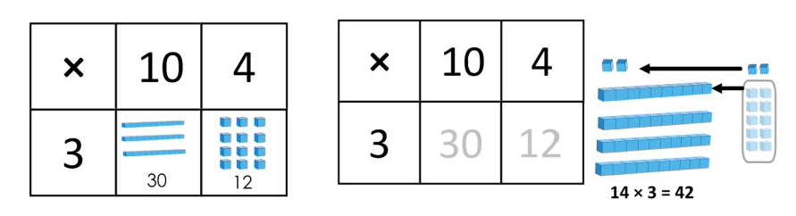  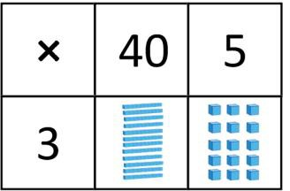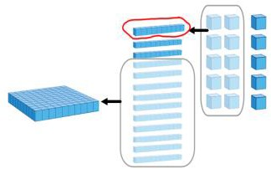

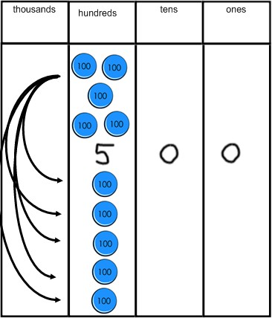

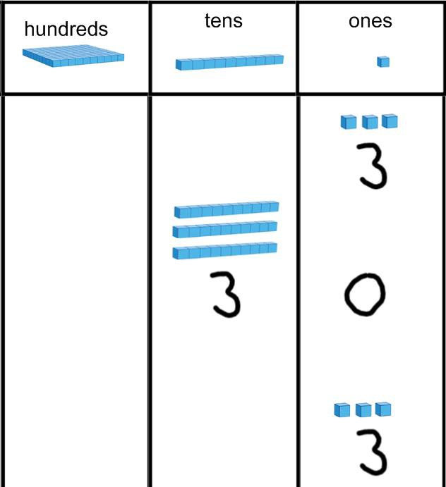
Y3 Division

Strategy & Guidance | CPA
Dividing multiples of 10, 100 and 1000 by  10, 100 and 1000  using scaling down  Pupils use the strategy of ‘scaling down’, representing numbers with concrete manipulatives and making the value ten times smaller. | 3 × 10 = 30  30 ÷ 10 = 3
Dividing multiples of 10, 100 and 1000 by  10, 100 and 1000  using grouping  Pupils divide by 10, 100 and 1000 by making groups of the divisor. | 500 ÷ 100 =  My whole is 500 and the value of the equal parts is 100. How many parts are there?

Progression in calculations Year 4
National curriculum objectives linked to addition and subtraction

These objectives are explicitly covered through the strategies outlined in this document:

- add and subtract numbers with up to four digits, using the formal written methods of columnar addition and subtraction where appropriate
- find 1 000 more or less than a given number

- estimate and use inverse operations to check answers to a calculation

N.B. There is no explicit reference to mental calculation strategies in the programmes of study for Year 4 in the national curriculum. However, with an overall aim for fluency, appropriate mental strategies should always be considered before resorting to formal written procedures, with the emphasis on pupils making their own choices from an increasingly sophisticated range of strategies.

The following objectives should be planned for lessons where new strategies are being introduced and developed:

- solve addition and subtraction two-step problems in contexts, deciding which operations and methods to use and why

- solve simple measure and money problems involving fractions and decimals to two decimal places

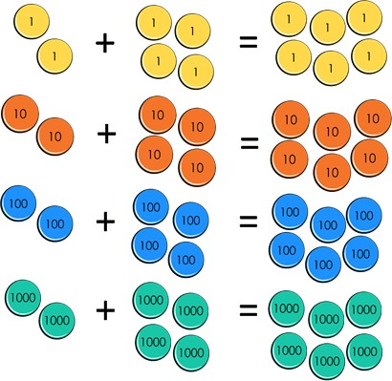
Y4 Addition & Subtraction

Strategies & Guidance | CPA
Count forwards and backwards in steps of 10, 100 and 1000 for any  number up to 10 000.  Pupils should count on and back in steps of ten, one hundred and one thousand from different starting points. These should be practised regularly, ensuring that boundaries where more than one digit changes are included.  Count forwards and backwards in tenths and hundredths | Pay particular attention to boundaries where regrouping happens more than once and so more than one digit changes.  E.g. 990 + 10 or 19.9 + 0.1
Using known facts and knowledge of place value to derive facts.  Add and subtract multiples of 10, 100 and 1000 mentally  Pupils extend this knowledge to mentally adding and subtracting multiples of 10, 100 and 1000. Counting in different  multiples of 10, 100 and 1000 should be incorporated into transition activities and practised regularly. | 2 + 4 = 6  20 + 40 = 60  200 + 400 = 600  2000 + 4000 = 6000
Adding and subtracting by partitioning one number and applying known facts.  By Year 4 pupils are confident in their place value knowledge and are calculating mentally both with calculations that do not require regrouping and with those that do. | See Y3 guidance on mental addition & subtraction, remembering that use of concrete manipulatives and images in both teaching and reasoning activities will help to secure understanding and develop mastery.

Strategies & Guidance | CPA
Round and adjust  Pupils should recognise that this strategy is useful when adding and subtracting near multiples of ten. They should apply their knowledge of rounding.  It is very easy to be confused about how to adjust and so visual representations and logical reasoning are essential to success with this strategy.  Build flexibility by completing the same calculation in a different order. | 3527 + 296 = 3827 - 4  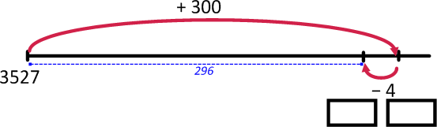  Completing the same calculation but adjusting first: 3527 + 296 = 3523 + 300  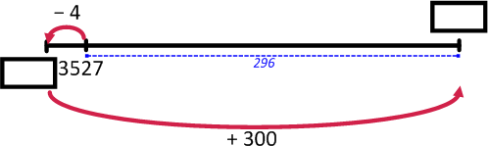  4523 – 3997 = 523 + 3  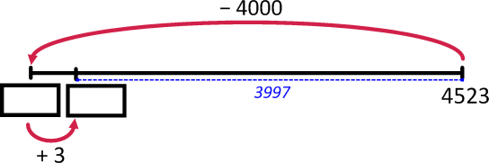  Completing the same calculation but adjusting first: 4523 – 3997 = 4526 - 4000  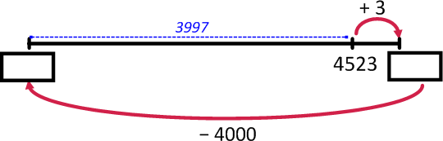
Near doubles  Pupils should be able to double numbers up to 100 and use this to derive doubles for multiples of ten. These facts can be adjusted to calculate near doubles. | 1600 + 1598 = double 1600 – 2  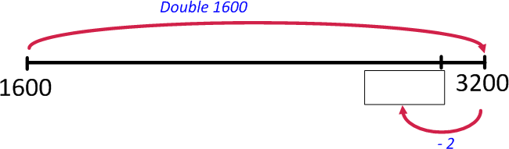

Strategies & Guidance | CPA
Written column methods for addition  Place value counters are a useful manipulative for representing the steps of the formal written method. These should be used alongside the written layout to ensure conceptual understanding and as a tool for explaining.  This method and the language to use are best understood through the tutorial videos found here on the toolkit. | 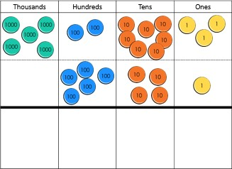  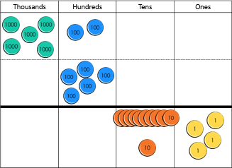  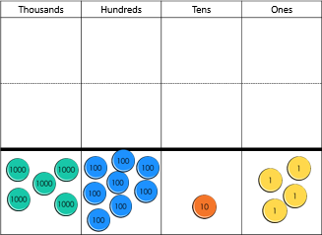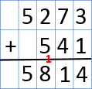
Written column methods for subtraction  Place value counters are a useful manipulative for representing the steps of the formal written method. These should be used alongside the written layout to ensure conceptual understanding and as a tool for explaining.  This method and the language to use are best understood through the tutorial videos on the toolkit. | 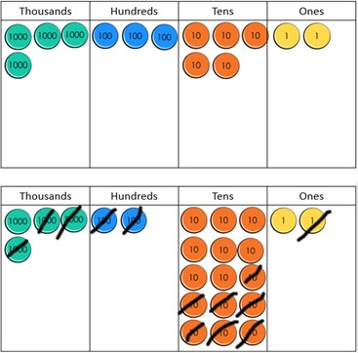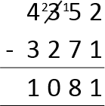

Strategies & Guidance | CPA
Calculating with decimal numbers  Assign different values to Dienes equipment. If a Dienes 100 block has the value of 1, then a tens rod has a value of  0.1 and a ones cube has a value of 0.01. These can then be used to build a conceptual understanding of the relationship between these.  Place value counters are another useful manipulative for representing decimal numbers.  All of the calculation strategies for integers (whole numbers) can be used to calculate with decimal numbers. | 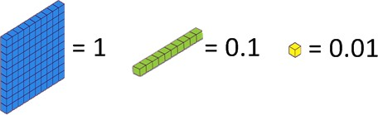  24.2 + 13.4 =  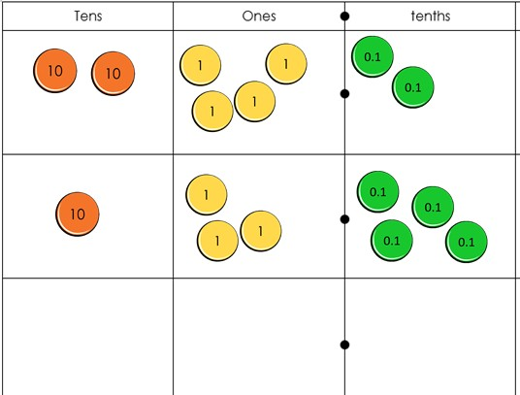

National Curriculum objectives linked to multiplication and division

These objectives are explicitly covered through the strategies outlined in this document:

- count from 0 in multiples of 6, 7, 9, 25 and 1000

- recall and use multiplication and division facts for multiplication tables up to 12 × 12

- write and calculate mathematical statements for multiplication and division using the multiplication tables that they know, including for two-digit numbers times one-digit numbers, using mental and progressing to formal written methods

- recognise and use factor pairs and commutativity in mental calculations

- use place value, known and derived facts to multiply and divide mentally, including: multiplying by 0 and 1; dividing by 1; multiplying together three numbers

- multiply two-digit and three-digit numbers by a one-digit number using formal written layout

- find the effect of dividing a one- or two-digit number by 10 and 100, identifying the value of the digits in the answer as ones, tenths and hundredths.

The following objectives should be planned for lessons where new strategies are being introduced and developed:

- solve problems involving multiplying and adding, including using the distributive law to multiply two digit numbers by one digit, integer scaling problems and harder correspondence problems such as n objects are connected to m objects.

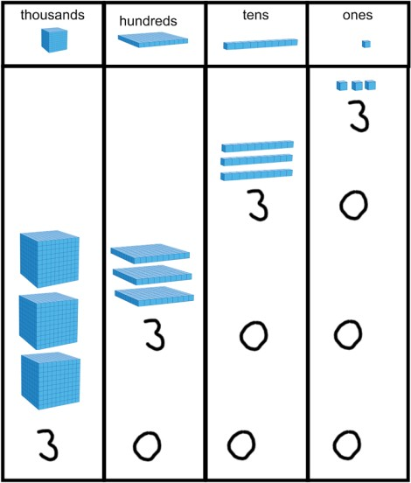
Y4 Multiplication

Strategies & Guidance | CPA
Multiplying by 10 and 100  When you multiply by ten, each part is ten times greater. The ones become tens, the tens become hundreds, etc.  When multiplying whole numbers, a zero holds a place so that each digit has a value that is ten times greater.  Repeated multiplication by ten will build an understanding of multiplying by 100 and 1000 | 3 x 10 = 30  3 x 100 = 300  3 x 1000 = 3000
Using known facts and place value for mental multiplication involving multiples of 10 and 100  Pupils use their growing knowledge of multiplication facts, place value and derived facts to multiply mentally.  Emphasis is placed on understanding the relationship (10 times or 100 times greater) between a known number fact and one to be derived, allowing far larger ‘fact families’ to be derived from a single known number fact.  Knowledge of commutativity (that multiplication can be completed in any order) is used to find a range of related facts. | 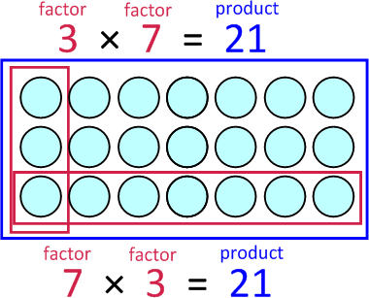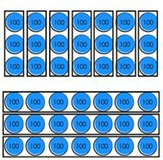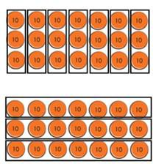  30 x 7 = 210 300 x 7 = 2100  70 x 3 = 210 700 x 3 = 2100  7 x 30 = 210 7 x 300 = 2100  3 x 70 = 210 3 x 700 = 2100

Strategies & Guidance | CPA
Multiplying by partitioning one number and multiplying each part  Pupils build on mental multiplication strategies and develop an explicit understanding of distributive law, which allows them to explore new strategies to make more efficient calculations.  As well as partitioning into tens and ones (a familiar strategy), they begin to explore compensating strategies and factorisation to find the most efficient solution to a calculation.  Distributive law  a x (b + c) = a x b + a x c | 14 x 6  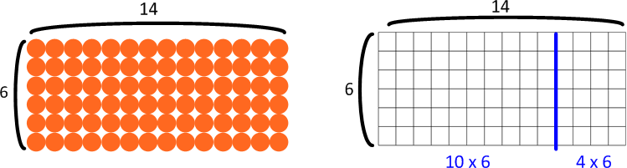  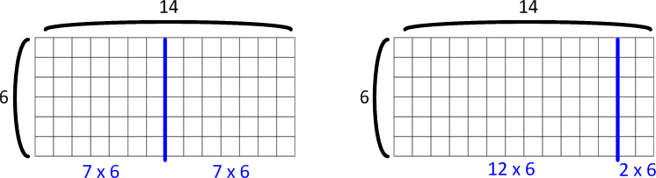  34 × 6  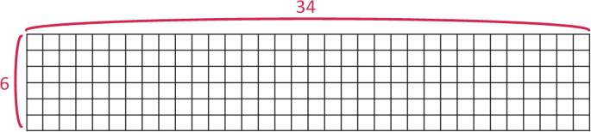  30 × 6 + 4 × 6  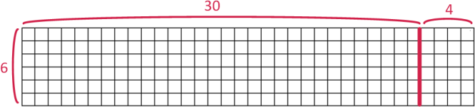
Mental multiplication of three 1- digit numbers, using the associative law  Pupils first learn that multiplication can be performed in any order, before applying this to choose the most efficient order to complete calculations, based on their increasingly sophisticated number facts and place value knowledge. | Four pots each containing two flowers which each have seven petals. How many petals in total?  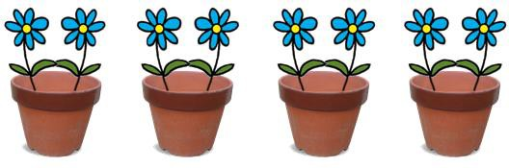  (4 x 2) x 7 or 4 x (2 x 7)

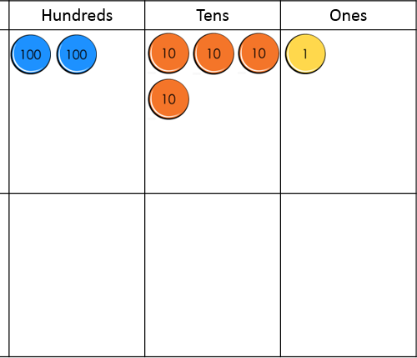
Strategies & Guidance | CPA
Short multiplication of 3-digit number by 1-digit number  To begin with pupils are presented with calculations that require no regrouping or only regrouping from the ones to the tens. Their conceptual understanding is supported by the use of place value counters, both during teacher demonstrations and during their own practice.  With practice pupils will be able to regroup in any column, including from the hundreds to the thousands, including being able to multiply numbers containing zero and regrouping through multiple columns in a single calculation.  This method and the language to use are best understood through the tutorial videos found here on the toolkit. | Exemplification of this process is best understood through viewing the video tutorial  To calculate 241 x 3, represent the number 241.  Multiply each part by 3, regrouping as needed.  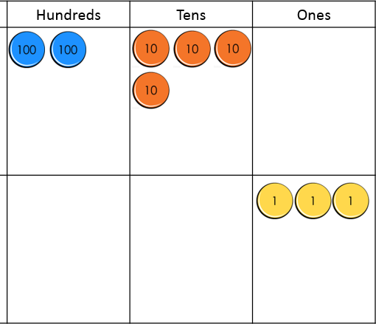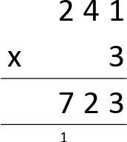  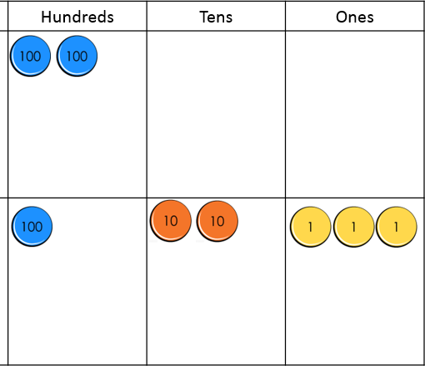  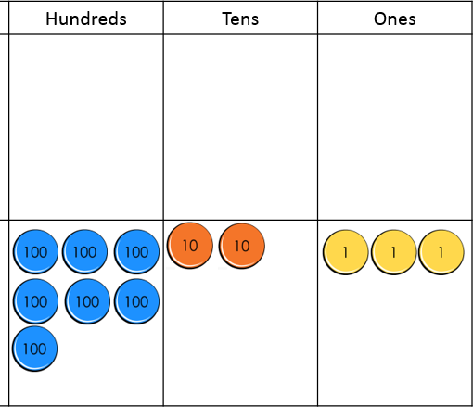

Y4 Division

Strategies & Guidance | CPA
Dividing by 10 and 100  When you divide by ten, each part is ten times smaller. The hundreds become tens and the tens become ones. Each digit is in a place that gives it a value that is ten times smaller.  When dividing multiples of ten, a place holder is no longer needed so that each digit has a value that is ten times smaller. E.g. 210 ÷ 10 = 21 | 30 ÷ 10 = 3  300 ÷ 100 = 3  3000 ÷ 1000 = 3  300 ÷ 10 = 30  3000 ÷ 100 = 30  3000 ÷ 10 = 300
Derived facts  Pupils use their growing knowledge of multiplication facts, place value and derived facts to multiply mentally.  Understanding of the inverse relationship between multiplication and division allows corresponding division facts to be derived. | 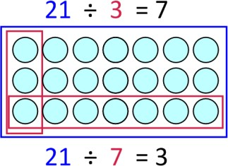  210 ÷ 7 = 30 2100 ÷ 7 = 300  210 ÷ 3 = 70 2100 ÷ 3 = 700  210 ÷ 30 = 7 2100 ÷ 300 = 7  210 ÷ 70 = 3 2100 ÷ 700 = 3

Strategies & Guidance | CPA
Short division of 4-digit numbers by 1-digit numbers  Pupils start with dividing 4-digit numbers by 2, 3 and 4, where no regrouping is required. Place value counters are used simultaneously in a place value chart, to develop conceptual understanding.  They progress to calculations that require regrouping in the hundreds or tens columns.  Pupils build on their conceptual knowledge of division to become confident with dividing numbers where the tens digit is smaller than the divisor, extending this to any digit being smaller than the divisor.  Exemplification of this method and the language to use are best understood through viewing the tutorial videos found here on the toolkit. | Division as sharing  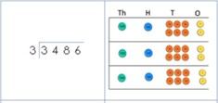  Division as grouping  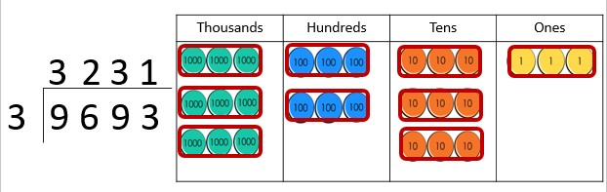
Division of a one- or two-digit number by 10 and 100, identifying the value of the digits in the answer as ones, tenths and hundredths  When you divide by ten, each part is ten times smaller. The tens become ones and the ones become tenths. Each digit is in a place that gives it a value that is ten times smaller. | 24 ÷ 10 = 2.4  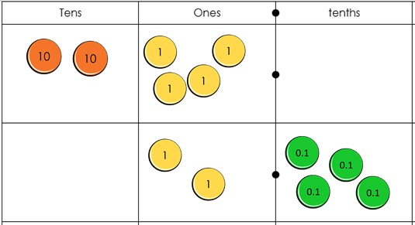  24 ÷ 100 = 0.24  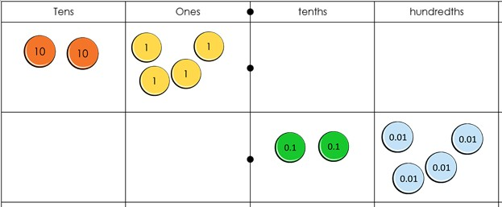

Progression in calculations Year 5 + Year 6
Year 5 and Year 6 are together because the calculation strategies used are broadly similar, with Year 6 using larger and smaller numbers. Any differences for Year 6 are highlighted in red.

National Curriculum objectives linked to integer addition and subtraction

These objectives are explicitly covered through the strategies outlined in this document:

- add and subtract numbers mentally with increasingly large numbers

- add and subtract whole numbers with more than 4 digits, including using formal written methods (columnar addition and subtraction)

- use negative numbers in context, and calculate intervals across zero

- perform mental calculations, including with mixed operations and large numbers

- use estimation to check answers to calculations and determine, in the context of a problem, an appropriate degree of accuracy

The following objectives should be planned for lessons where new strategies are being introduced and developed:
- use rounding to check answers to calculations and determine, in the context of a problem, levels of accuracy
- solve addition and subtraction multi-step problems in contexts, deciding which operations and methods to use and why
- solve problems involving addition, subtraction, multiplication and division and a combination of these, including understanding the meaning of the equals sign.

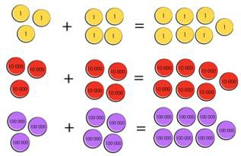
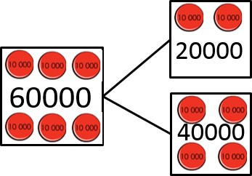
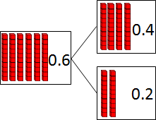

Y5 and Y6 Addition & Subtraction

Strategies & Guidance | CPA
Count forwards or backwards in steps of powers of 10 for any given number up to 1 000 000  Skip counting forwards and backwards in steps of powers of 10 (i.e. 10, 100, 1000, 10 000  and 100 000) should be incorporated into transition activities and practised regularly.  In Year 5 pupils work with numbers up to 1 000 000 as well as tenths, hundredths and thousandths.  In Year 6 pupils work with numbers up to 10 000 000. | Support with place value counters on a place value chart, repeatedly adding the same counter and regrouping as needed.  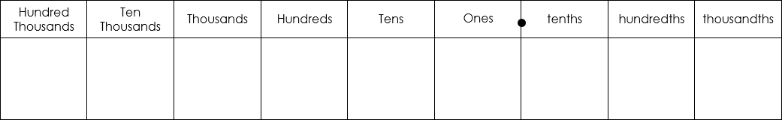  Counting sticks and number lines:  Pay particular attention to boundaries where regrouping happens more than once and so more than one digit changes. e.g. 9900 + 100 = 10 000 or 99 000 + 1000 = 100 000
Using known facts and understanding of place value to derive  Using the following language makes the logic explicit: I know three ones plus four ones is equal to seven ones. Therefore, three ten thousands plus four ten thousands is equal to seven ten thousands.  In Year 5 extend to multiples of 10 000 and 100 000 as well as tenths, hundredths and thousandths.  In Year 6 extend to multiples of one million.  These derived facts should be used to estimate and check answers to calculations. | 3 + 4 = 7  30 000 + 40 000 = 70 000  300 000 + 400 000 = 700 000  20 000 + 40 000 = 60 000  40 000 + 20 000 = 60 000  60 000 - 40 000 = 20 000  60 000 - 20 000 = 40 000  0.6 = 0.2 + 0.4  0.6 = 0.4 + 0.2  0.2 = 0.6 - 0.4  0.4 = 0.6 - 0.2

Strategies & Guidance | CPA
Partitioning one number and applying known facts to add.  Pupils can use this strategy mentally or with jottings as needed.  Pupils should be aware of the range of choices available when deciding how to partition the number that is to be added.  They should be encouraged to count on from the number of greater value as this will be more efficient. However, they should have an understanding of the commutative law of addition, that the parts can be added in any order.  Pupils have experience with these strategies with smaller numbers from previous years and so the focus should be on developing flexibility and exploring efficiency. | Partitioning into place value amounts (canonical partitioning):  4650 + 7326 = 7326 + 4000 + 600 + 50  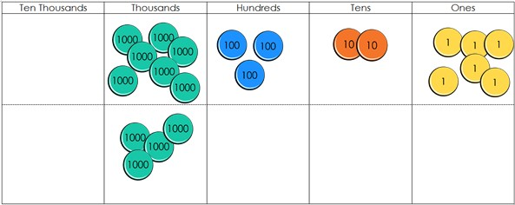  With place value counters, represent the larger number and then add each place value part of the other number. The image above shows the thousands being added.  Represent pictorially with an empty numberline:  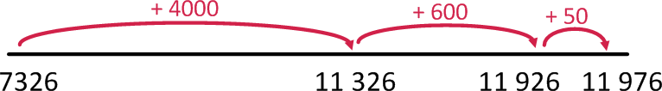  Partitioning in different ways (non-canonical partitioning):  Extend the ‘Make ten’ strategy (see guidance in Y1 or Y2) to  count on to a multiple of 10.  6785 + 2325 = 6785 + 15 + 200 + 2110  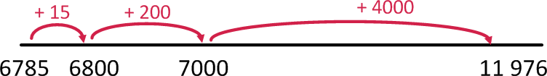  The strategy can be used with decimal numbers, Make one: 14.7 + 3.6 = 14.7 + 0.3 + 3.3 = 15 + 3.3  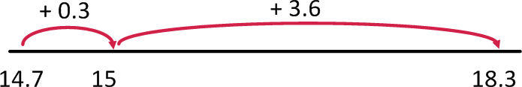

Strategies & Guidance | CPA
Subtraction by partitioning and applying known facts.  Pupils can use this strategy mentally or with jottings as needed.  Pupils should be aware of the range of choices available when deciding how to partition the number that is to be subtracted.  Pupils have experience with these strategies with smaller numbers from previous years and so the focus should be on developing flexibility and exploring efficiency. | Partitioning into place value amounts (canonical partitioning):  75 221 – 14 300 = 75 221 – 10 000 – 4000 – 300  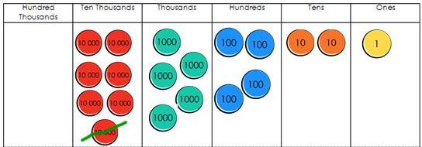  Represent pictorially with a number line, starting on the right and having the arrows jump to the left:  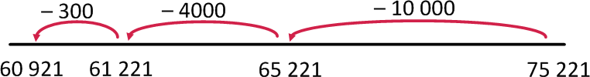  Develop understanding that the parts can be subtracted in any order and the result will be the same:  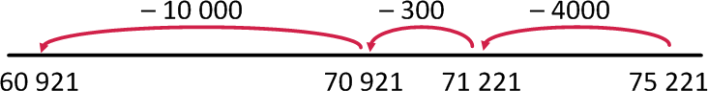  Partitioning in different ways (non-canonical partitioning):  Extend the ‘Make ten’ strategy (see guidance in Y1 or Y2) to  count back to a multiple of 10.  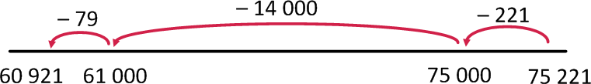

Strategies & Guidance | CPA
Calculate difference by  “counting back”  It is interesting to note that finding the difference is reversible. For example, the difference between 5 and 2 is the same as the difference between 2 and 5. This is not the case for other subtraction concepts. | 75 221 – 14 300  Place the numbers either end of a numberline and work out the difference between them. Select efficient jumps.  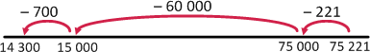  Finding the difference is efficient when the numbers are close to each other:  9012 – 8976  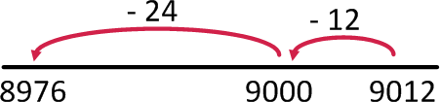
Calculate difference by  “counting on”  Addition strategies can be used to find difference. | 75 221 – 14 300  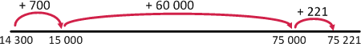  Finding the difference is efficient when the numbers are close to each other  9012 – 8976  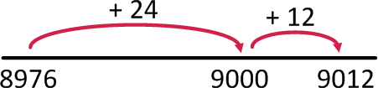

Strategies & Guidance | CPA
Round and adjust  Addition and subtraction using compensation  Pupils should recognise that this strategy is useful when adding and subtracting near multiples of ten. They should apply their knowledge of rounding.  It is very easy to be confused about how to adjust and so visual representations and logical reasoning are essential to success with this strategy. | Addition  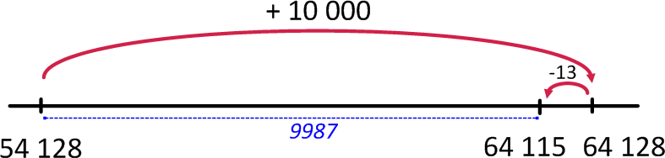  54 128 + 9987 = 54 128 + 10 000 – 13 = 64128 - 13  Pupils should realise that they can adjust first:  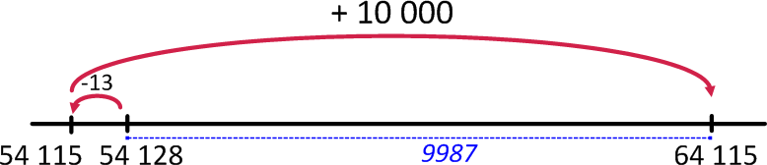  54128 + 9987 = 54128 – 13 + 10 000 = 54 115 + 10 000  Subtraction  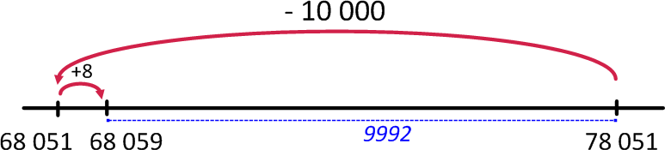  78 051 – 9992 = 78 051 – 10 000 + 8 = 68 051 + 8  Pupils should realise that they can adjust first:  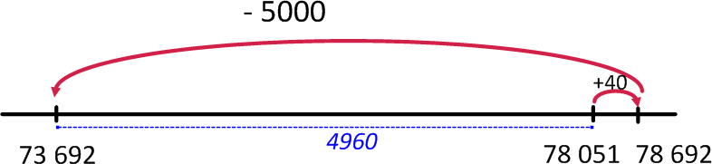  78 051 – 4960 = 78 051 + 40 – 5000 = 78 692 - 5000
Near doubles  Pupils should be able to double numbers up to 100 and use this to derive doubles for multiples of ten as well as decimal numbers. These facts can be adjusted to calculate near doubles. | 160 + 170 = double 150 + 10 + 20  160 + 170 = double 160 + 10 or 160 + 170 = double 170 - 10  2.5 + 2.6 = double 2.5 + 0.1

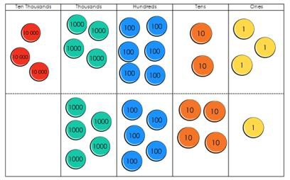
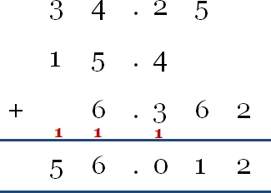
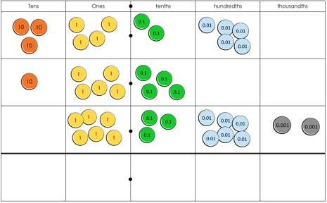
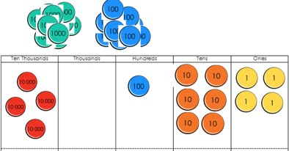

Strategies & Guidance | CPA
Partition both numbers and combine the parts  Pupils should be secure with this method for numbers up to 10 000, using place value counters or Dienes to show conceptual understanding.  If multiple regroupings are required, then pupils should consider using the column method. | 7230 + 5310 = 12 000 + 500 + 40  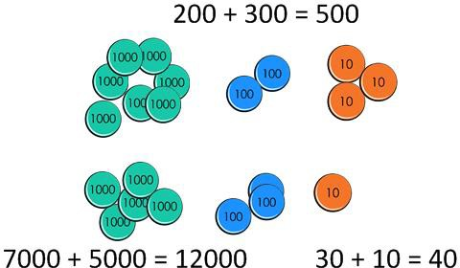  Pupils should be aware that the parts can be added in any order.
Written column methods for addition  In Year 5, pupils are expected to be able to use formal written methods to add whole numbers with more than four digits as well as working with numbers with up to three decimal places.  Pupils should think about whether this is the most efficient method, considering if mental methods would be more effective.  Continue to use concrete manipulatives alongside the formal method.  When adding decimal numbers with a different number of decimal places, in order to avoid calculation errors, pupils should be encouraged to insert zeros so that there is a digit in every row. This is not necessary for calculation and these zeros are not place holders as the value of the other digits is not changed by it being placed.  Exemplification of this method and the language to use are best understood through viewing the tutorial videos found here on the toolkit. | For this method start with the digit of least value because if regrouping happens it will affect the digits of greater value.  3 4 6 2 3  + 5 5 4 1  Combine the counters in each column and regroup as needed:  3 4 6 2 3  + 5 5 4 1  1 1  4 0 1 6 4  Decimal numbers:

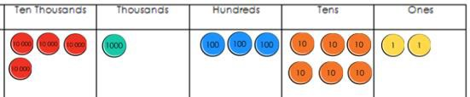
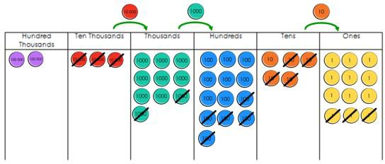

Strategies & Guidance | CPA
Written column methods for subtraction  In Year 5, pupils are expected to be able to use formal written methods to subtract whole numbers with more than four digits as well as working with numbers with up to three decimal places.  Pupils should be given plenty of practice with calculations that require multiple separate instances of regrouping.  In Year 3 and 4 they become more familiar with calculations that require ‘regrouping to regroup’. Understanding must be secured through the considered use of manipulatives and images, combined with careful use of language.  Pupils should think about if this is the most efficient method, considering whether mental strategies (such as counting on, using known number facts, compensation etc.) may be likelier to produce an accurate solution.  Exemplification of this method and the language to use are best understood through viewing the tutorial videos found here on the toolkit. | 4 1 3 6 2  - 3 2 2 4 3  3 1 5 1  4 1 3 6 2  - 3 2 2 4 3  9 1 1 9  The term regrouping should be the language used. You can use the terms ‘exchange’ with subtraction but it needs careful consideration.  You can regroup 62 as 50 and 12 (5 tens and 12 ones) instead of  60 and 2 (6 tens and 12 ones).  Or you can ‘exchange’ one of the tens for 10 ones resulting in 5  tens and 12 ones.  If you have exchanged, then the number has been regrouped.

Progression in calculations Year 5 + Year 6
National Curriculum objectives linked to multiplication and division

These objectives are explicitly covered through the strategies outlined in this document:

- multiply and divide whole numbers by 10, 100 and 1000

- multiply numbers up to 4 digits by a one- or two-digit number using a formal written method, including long multiplication for two-digit numbers
- multiply and divide numbers mentally drawing upon known facts

- divide numbers up to 4 digits by a one-digit number using the formal written method of short division and interpret remainders appropriately for the context
- multiply multi-digit numbers up to 4 digits by a two-digit whole number using the formal written method of long multiplication
- divide numbers up to 4 digits by a two-digit whole number using the formal written method of long division, and interpret remainders as whole number remainders, fractions, or by rounding, as appropriate for the context

- divide numbers up to 4 digits by a two-digit number using the formal written method of short division where appropriate, interpreting remainders according to the context

- multiply one-digit numbers with up to two decimal places by whole numbers

- use written division methods in cases where the answer has up to two decimal places

The following objectives should be planned for lessons where new strategies are being introduced and developed:
- solve problems involving multiplication and division including using their knowledge of factors and multiples, squares and cubes
- solve problems involving addition, subtraction, multiplication and division and a combination of these, including understanding the meaning of the equals sign
- use their knowledge of the order of operations to carry out calculations involving the four operations
- solve addition and subtraction multi-step problems in contexts, deciding which operations and methods to use and why
- solve problems involving addition, subtraction, multiplication and division

- solve problems involving the relative sizes of two quantities where missing values can be found by using integer multiplication and division facts.

Y5 and Y6 Multiplication

Strategies & Guidance | CPA
Multiply and divide whole numbers and those involving decimals by 10, 100 and 1000  Avoid saying that you “add a zero” when multiplying by ten and instead use the language of place holder.  Use place value counters and charts to visualise and then notice what happens to the digits. | When you multiply by ten, each part is ten times greater. The ones become tens, the tens become hundreds, etc.  When multiplying whole numbers, a zero holds a place so that each digit has a value that is ten times greater.  102.14 x 10 = 1021.4  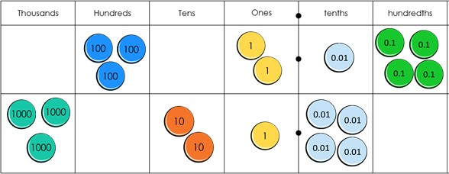  When you divide by ten, each part is ten times smaller. The hundreds become tens and the tens become ones. Each digit is in a place that gives it a value that is ten times smaller.  When dividing multiples of ten, a place holder is no longer needed so that each digit has a value that is ten times smaller.  E.g. 210 ÷ 10 = 21  210.3 ÷ 10 = 21.03  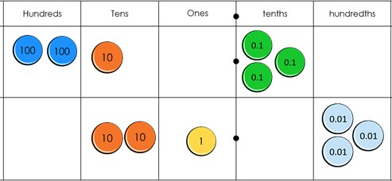

Strategies & Guidance | CPA
Using known facts and place value to derive multiplication facts  Emphasis is placed on understanding the relationship (10 times or 100 times greater) between a known number fact and one to be derived, allowing far larger ‘fact families’ to be derived from a single known number fact.  Knowledge of commutativity is further extended and applied to find a range of related facts.  Pupils should work with decimals with up to two decimal places.  These derived facts should be used to estimate and check answers to calculations. | 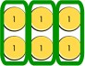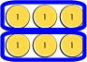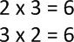  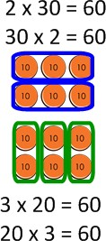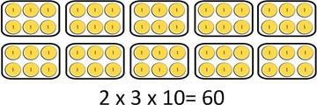  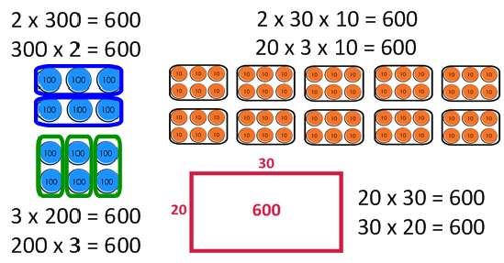
These are the multiplication facts pupils should be able to derive from a known fact

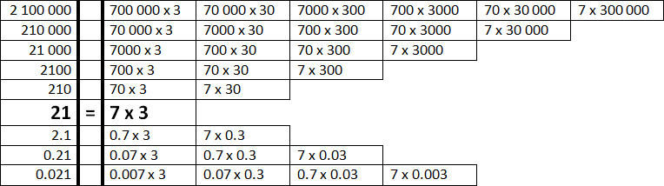

Strategies & Guidance | CPA
Doubling and halving  Pupils should experience doubling and halving larger and smaller numbers as they expand their understanding of the number system.  Doubling and halving can then be used in larger calculations. | 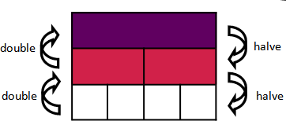  Multiply by 4 by doubling and doubling again e.g. 16 × 4 = 32 × 2 = 64  Divide by 4 by halving and halving again  e.g. 104 ÷ 4 = 52 ÷ 2 = 26
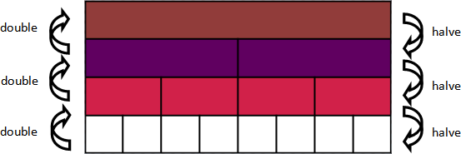

Multiply by 8 by doubling three times e.g. 12 × 8 = 24 × 4 = 48 × 2 = 96
Divide by 8 by halving three times

e.g. 104 ÷ 8 = 52 ÷ 4 = 26 ÷ 2 = 13
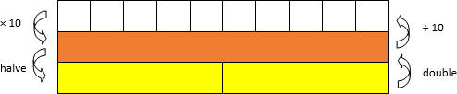

Multiply by 5 by multiplying by 10 then halving, e.g. 18 × 5 = 180 ÷ 2 = 90.
Divide by 5 by dividing by 10 and doubling,

e.g. 460 ÷ 5 = double 46 = 92

Strategies & Guidance | CPA
Multiply by partitioning one number and multiplying each part  Distributive law  a x (b + c) = a x b + a x c  Build on pupils’ understanding of arrays of counters to represent multiplication to see that area models can be a useful representation: | 8 x 14 = 8 x 10 + 8 x 4  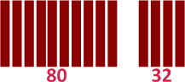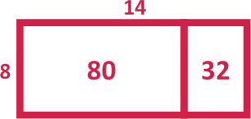  Cuisenaire rods to build arrays Represent with area model  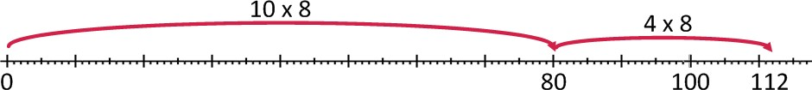  Jottings on a number line  Bead string where each bead has a value of 8:  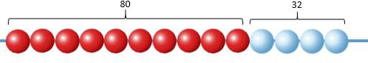
Using knowledge of factors  In Year 5 pupils are expected to be able to identify factor pairs and this knowledge can be used to calculate.  Pupils will be using the commutative and associative laws of multiplication.  Commutative law a x b = b x a Associative law  a x b x c = (a x b) x c  = a x (b x c)  They should explore and compare the different options and choose the most efficient order to complete calculations. | Calculate 6 x 24 by using factor pairs of 24  Two and twelve are factors of 24:  6 x 2 x 12 6 x 12 x 2  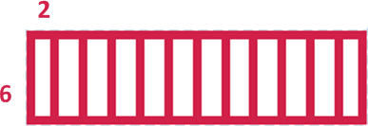  Three and eight are factors of 24:  6 x 3 x 8 6 x 8 x 3  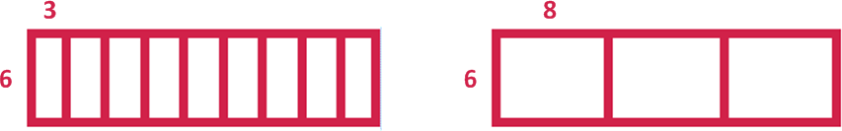  Four and six are factors of 24:  6 x 4 x 6 6 x 6 x 4  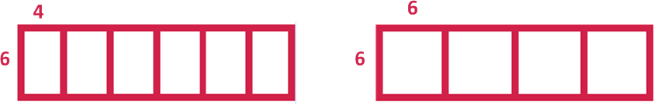

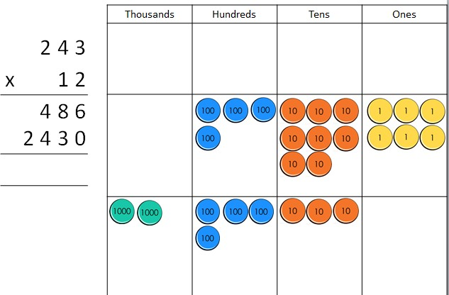
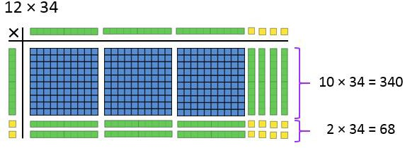
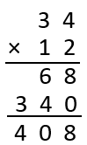
Strategies & Guidance | CPA
Formal written method of short multiplication
Conceptual understanding is supported by the use of place value counters, both during teacher demonstrations and during their own practice.

Exemplification of this method and the language to use are best understood through viewing the tutorial videos found here on the toolkit.
Multiplying by a 2-digit number  Formal written method of long multiplication  In Year 6 pupils are extended from multiplication by a 1- digit number to multiplication by a 2-digit number.  Extend the place value chart model used in Year 4, using an additional row on the place value chart.  Extend understanding of the distrubitive law to develop conceptual understanding of the two rows of the formal written method.  Dienes blocks can be used to construct area models to represent this. | 243 x 2  243 x 10

Y5 and Y6 Division

Strategies & Guidance | CPA
Deriving facts from known facts  Pupils use their growing knowledge of multiplication facts, place value and derived facts to multiply mentally.  Understanding of the inverse relationship between multiplication and division allows corresponding division facts to be derived. | 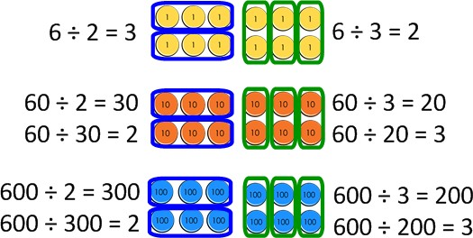
Using knowledge of multiples to divide  Using an area model to partition the whole into multiples of the divisor (the number you are dividing by). | 112 ÷ 8 = 80 ÷ 8 + 32 ÷ 8  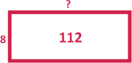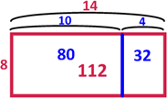  1260 ÷ 6 = 1200 ÷ 6 + 60 ÷ 6  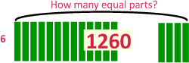  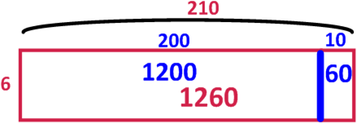

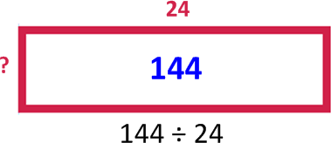
Strategies & Guidance | CPA
Using knowledge of factors to divide  Pupils explore this strategy when using repeated halving.  2 x 2 = 4 and so if you divide by 4 the same result can be achieved by dividing by two and then by two again. | I know 2 and 12 are a factor pair of 24 and so I can divide by 2 and then by 12.  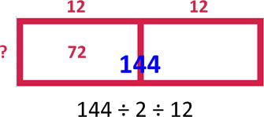

Strategies & Guidance | CPA
Short division  Dividing a 4-digit numbers by 1-digit numbers  The thought process of the traditional algorithm is as follows:  How many 4s in 8? 2  How many 4s in 5? 1 with 1 remaining so regroup.  How many 4s in 12? 3  How many 4s in 8? 2  Warning: If you simply apply place value knowledge to each step, the thinking goes wrong if you have to regroup.  How many 4s in 8000? 2000 How many 4s in 500?  100 with 1 remaining (illogical) The answer would be 125.  Sharing the dividend builds conceptual understanding however doesn’t scaffold the “thinking” of the algorithm.  Using place value counters and finding groups of the divisor for each power of ten will build conceptual understanding of the short division algorithm.  Area models are also useful representations, as seen with other strategies and exemplified for long division.  Exemplification of this method and the language to use are best understood through viewing the tutorial videos found here on the toolkit. | 8528 ÷ 4  Sharing 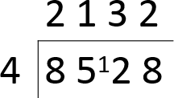  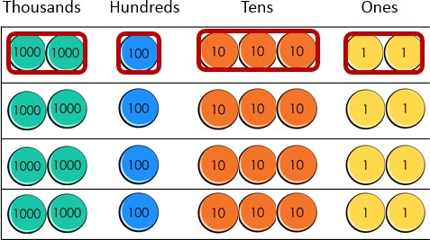  8 thousands shared into 4 equal groups 5 hundreds shared into 4 equal groups Regroup 1 hundred for 10 tens  12 tens shared into 4 equal groups 8 ones shared into 4 equal groups.  Grouping  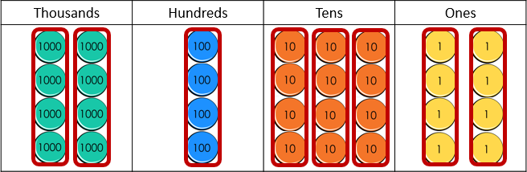  How many groups of 4 thousands in 8 thousands? How many groups of 4 hundreds in 5 hundreds? Regroup 1 hundred for 10 tens.  How many groups of 4 tens in 12 tens? How many groups of 4 ones in 8 ones?

Strategies & Guidance | CPA
Long division  Dividing a 4-digit number by a 2-digit number  Follow the language structures of the short division strategy. Instead of recording the regrouped amounts as small digits the numbers are written out below. This can be easier to work with when dividing by larger numbers.  If dividing by a number outside of their known facts, pupils should start by recording some multiples of that number to scaffold. | 